The Story of Manomi

Kabima village, Tahoua Region, Niger

Loetitia Raymond – August 2005

To reach the tiny, remote village where CARE is distributing food, you have to travel through a 120-mile stretch of arid land that begins at Koni, in the Tahoua region. The first miles are on a vaguely tarred road that crosses sparse vegetation. The red, laterite soil discourages the thin plantings that sprout here and there. Much later, the road ends and some 45 miles of trail run through a no-man’s land before ending in a village of mud constructions. The immensity of the semi-desert seems to continue endlessly. The village of Kabima is lost in the brush, far from crossroads and local markets. It is difficult to imagine such isolation. And yet 180 families live here as farmers. Before CARE, no other organization had attempted to help such a far flung community, too complicated in terms of access, which is precisely the reason they are so needy.

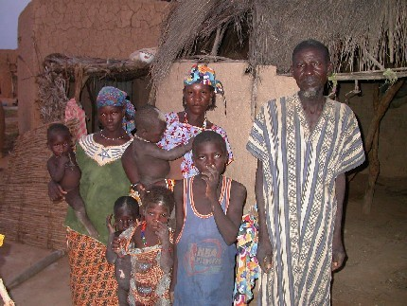
These Hausa are millet farmers for the most part. A few peanut and sorghum plants grow here and there. The women also cultivate some sorrel and gumbo. Manomi Maïgomo has lived here in Kabima for a long time. Difficult to know how long, since here the years are counted in terms of rainy seasons; as you move back in time, memory wavers. If we learn that he is about 60, we will not learn the age of his wife, who does not know it herself. Judging by the youthful appearance of Haoua Nouhou, Manomi’s second wife, she is 25, or at the most 28. Of Manomi’s 15 children, 11 are still living. In a country where one in four children do not live past the age of 5, he has been lucky.

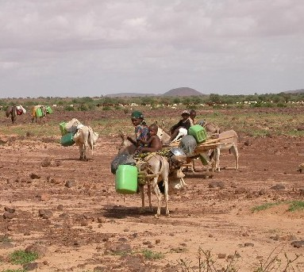
A great deal of millet is needed to feed all these mouths. In exceptional times Manomi harvests 200 sheaves. One sheaf makes five tia, a measure that equals 2.5 kilograms (just over five pounds), making a total of 2,500 kilos per year. But the last such harvest was in 2001; since then he harvests between 40 and 50 sheaves, just enough to feed his family for two months. And after these two, maybe four months, what can they do? Like the majority of the village men, Manomi markets his skills as a laborer to the “rich” farmers who are barely better off than the others, or he leaves for neighboring countries, hoping to find work. At the end of last year, when the current crisis began to take shape, Manomi did this. A poor rainfall presaged a bad harvest. Then came the locusts that in only a few short hours devastated the crops in parts of the country.

Manomi remembers the unlucky day that plunged them into desperation: it was the middle of an August afternoon. Suddenly, a black cloud came towards the village.

“The sky turned black and we couldn’t see the sun. The locusts came at two o’clock. They ate and when they had finished at 10 the next morning, they left.” The villagers looked on dumbfounded and helpless as the locusts destroyed a year’s work in a few hours. Nothing remained, not even one ear of the young millet.

Looking at his ravaged fields, Manomi felt himself grow faint. He immediately was obsessed with the idea of finding a solution, to leave and quickly find work so as to feed his wife and children. He explained to his wife that fate had dealt them a blow and the only solution was that he leave her alone. He left her with no money in the hope of earning a few cents elsewhere.

During his absence, his wife Haoua offered her services transporting water for the rich. She earned 25 to 75 francs (from 5 to 15¢) depending on the distance crossed to carry 10 gallons of water. Her parents helped her as much as they could until her husband fell ill and returned to Kabima. As the weeks passed, the situation became more critical for Manomi and all Nigerien farmers. The people of Kabima recount their distress, which grew until the recent arrival of food brought by CARE:

“We searched in all the ant hills around here. Ants stock grain and we managed to find a few hundred grams of millet here and there. We were so hungry that we began to eat leaves, at first from the giga plant, then bagga and tafasa.”

Finally they were obliged to eat the anza, a plant so bitter and indigestible that it has to be soaked and rinsed several times to make it minimally edible.

“We had to be truly starving to try to eat it. Anza was our last chance.”

The entire village gathers to give warm thanks for the arrival of the CARE food aid, which they characterize as “miraculous” and “a gift from the sky.”

“Without it, we do not know how we would have survived. Two days had already gone by without my being able to give anything to the children. I had to go to distant family to get a bit of millet, but it wouldn’t have lasted very long,” says Manomi.

These days, Manomi has been woking one day in his own field and the next in the field of more affluent owners.

“Usually this food would last for fifteen days if I were working in my own field, but if I continue to work for others, I can hold out for one month with this aid, almost until the next harvest, about a month and a half or two months off. We should be able to manage,” Manomi confides.

Everyone hopes that the harvest will be good, that there will be enough rain. Seeds had to be sown three times before the plants began to grow: capricious rainfall killed the first two plantings. For the second sowing, villagers had to go to the neighbors for seed, the third time, seed came from other villages because nothing remained in Kabima.

Manomi expresses his gratitude without reserve.

“Today we will eat our fill, and I will have the energy to labor in the fields.”

But today is not the first time CARE has visited Kabima. Our non-emergency programs are active here, too.

“Thanks to CARE, I’ve been able to plant new crops with the agricultural development project. The techniques I’ve learned allow me to work land that had been infertile.” Manomi notes too that a literacy center was created, and that CARE paid villagers in food for their construction labor.

“CARE has reinforced our land management capacities and what we are going through has been catastrophic, just when our situation had started to improve. Fortunately, today we have more cultivable land. Even given this crisis, if this year’s rains are good we will have a larger harvest because we cultivated more land thanks to CARE’s intervention.”

